Business Question and Visualization Report

Team ID | MCA
Project Name | Smartphone Usage, Digital Addiction & Well-Being Analytics
Maximum Marks | 5 Marks

Visualization development refers to the process of creating graphical representations of data to facilitate understanding, analysis, and decision-making. The goal is to transform complex datasets into visual formats that are easy to interpret, enabling users to gain insights and make informed decisions. Visualization development involves selecting appropriate visual elements, designing layouts, and using interactive features to enhance the user experience. This process is commonly associated with data visualization tools and platforms, and it plays a crucial role in business intelligence, analytics, and reporting
Business Questions and Visualisation
The process involves defining specific business questions to guide the creation of meaningful and actionable visualizations in Power BI. Well-framed questions help in identifying key metrics, selecting relevant data, and building visualisation that provide insights.

1.Is there a significant variation in phone dependency when grouped by user gender?
- Visualization: Clustered Bar Chart tracking Average Daily Screen Time by Gender (Male, Female, Other).
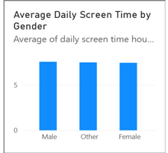

2.How are the 7,500 active users distributed across explicit clinical addiction level metrics?
- Visualization: Horizontal Bar Chart mapping Users by Addiction Level (Severe, Moderate, Mild, None).
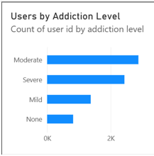

3.What is the exact percentage breakdown of individuals flagged as digitally addicted within our database?
- Visualization: Donut Chart (Addicted vs Non-Addicted Users) showing a central volume of 7.5K rows with a 29.23% true positive rate.
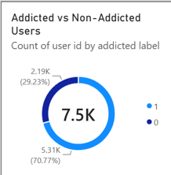

4.Which target demographic age bracket exhibits the highest daily screen time baseline scores?
- Visualization: Clustered Column Chart comparing Average Daily Screen Time by Age Group (Under 20, 20-29, 30-39).
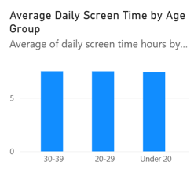

5.Is there a visible correlation between a user's daily total screen time hours and their nightly sleep logs?
- Visualization: Scatter Plot mapping daily screen time hours and sleep hours across a dense, custom-masked point distribution block.
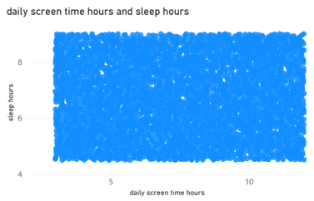

6.How does intensive mobile gaming duration compare directly against active social media engagement loops?
- Visualization: Dual-Clustered Column Chart (Average Gaming vs Social Media Usage) plotting behavioral category means side by side.
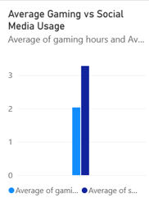

7.How can dashboard consumers dynamically filter the dataset by age cohort and gender variables simultaneously?
- Visualization: Interactive Vertical Slicer Checkbox Menus configured for gender and Age Group parameters.
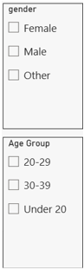

8.How can tracking parents or administrators isolate specific behavioral severities dynamically across charts?
- Visualization: Interactive Vertical Slicer Checklist configured exclusively for user addiction level tags.
